### **Breast Cancer Image Classification Report**

**Introduction:**

Breast cancer is a prevalent health concern globally, with early and accurate diagnosis crucial for effective treatment. Deep learning techniques offer significant potential for improving breast cancer image classification. This report describes the development and evaluation of a deep learning model for this purpose.

**Dataset Description:**

The project utilizes a breast cancer dataset containing 4000 images from various sources. The dataset is divided into two classes: negative (benign) and positive (malignant), each containing 2000 images. A balanced dataset is crucial for training effective classification models.

**Model Architecture:**

A pre-trained ResNet-18 convolutional neural network (CNN) serves as the foundation of the model. Pre-trained models leverage knowledge gained from solving similar tasks, accelerating learning and improving performance. Here, the final fully connected layer of the pre-trained model is replaced with a new layer designed for binary classification (benign or malignant).

**Training Process:**

The training method involves loading and pre-processing the breast cancer dataset (resizing, normalization). A pre-trained ResNet-18 CNN serves as the base, with the last fully connected layer substituted for binary classification (benign/malignant). The cross-entropy loss function calculates prediction errors, and the SGD optimizer modifies model parameters. Training iterates across 20 epochs, feeding picture batches, making predictions, measuring loss, and modifying parameters to reduce future losses. Validation with a distinct set provides generalizability, also storing loss and accuracy on train and validation data during every epoch while the final assessment measures performance on test data.

**Evaluation Results:**

After 20 epochs of training, the model attained a training loss of 0.430 and a training accuracy of 84.837%. Concurrently, the validation loss amounted to 0.408, with a corresponding validation accuracy of 87.719%. Additionally, the testing accuracy was measured at 83.55%. While these metrics provide insight into the model's performance, further evaluation through metrics such as precision, recall, and F1 score can offer a more comprehensive understanding of its proficiency in distinguishing between benign and malignant images.

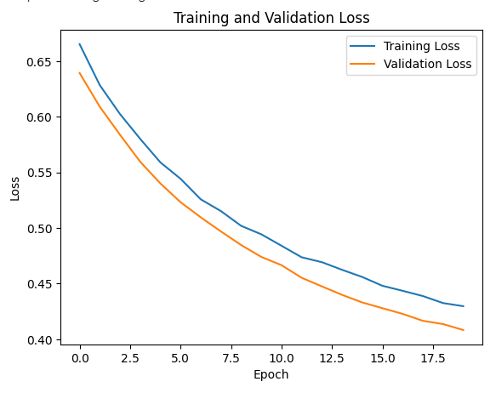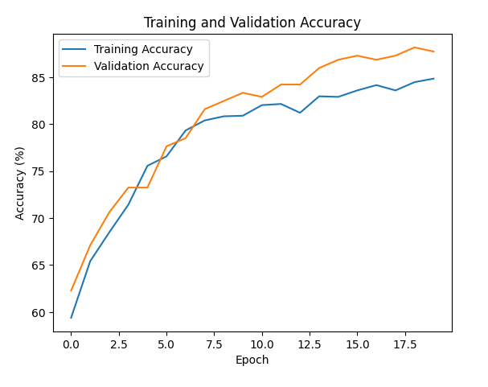

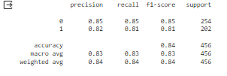

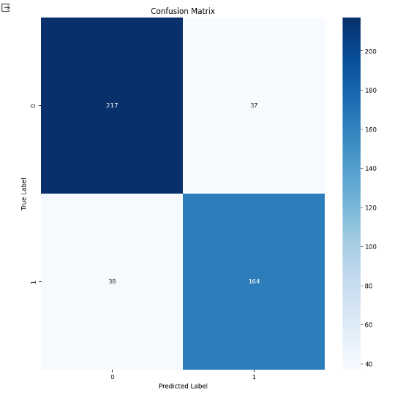

**Conclusion:**

In conclusion, the project has successfully developed a breast cancer image classification model capable of accurately categorizing images as benign or malignant. While achieving promising results, there are opportunities for improvement, including fine-tuning the model architecture and exploring additional data augmentation techniques to enhance performance further.

**Future Considerations:**

* This report focuses on initial model development. Further work should involve testing the model on a larger, independent dataset to ensure generalizability and robustness.
* Ethical considerations, such as potential biases in the training data and the need for human supervision, require careful attention in real-world applications.
* Regulatory aspects of deploying such models in clinical settings need to be addressed.

By continuing to develop and refine this model, it has the potential to become a valuable tool for breast cancer diagnosis, ultimately contributing to improved patient care.